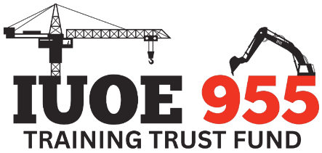

Reimbursement Request
Name | Click or tap here to enter text. | Date | Click or tap to enter a date.
Email | Click or tap here to enter text. | Phone | Click or tap here to enter text.
Union Reg # | Click or tap here to enter text.

COURSE INFORMATION
Completion Date Course Name Cost
- Date | cOURSE NAME |  | $
2. DATE | COURSE NAME |  | $
- DATE | COURSE NAME |  | $
 | TOTAL |  | $

Reimbursements are now issued via Electronic Funds Transfer (EFT). To ensure accuracy and financial security, we cannot accept handwritten direct deposit information. Operating Engineers Apprenticeship and Education is committed to safeguarding members’ personal information and manages all data in accordance with Alberta’s Personal Information Protection Act (PIPA).
Please email the completed form, along with your invoice, proof of course completion, payment receipts, and direct deposit information (Direct Deposit form or void cheque), to reimbursements@oe955.com.
Remember to update your TRADES WALLET!

For Office use only
Prior Reimbursements to Date | Click or tap here to enter text.

